**Mathematics for Engineers – II**

ANALYSIS OF INDIAN CRICKET TEAM AND THEIR STRATGIES

REPORT ON THE PROJECT SUBMITTED AS PARTIAL FULFILLMENT FOR THE AWARD OF DEGREE BACHELOR OF TECHNOLOGY

**IN COMPUTER SCIENCE ENGINEERING**

SUBMITTED BY -

MAITRI SHARMA 220400

ARYASHRESTHA SAGAR 220337

MAYANK PRATAP SINGH 220363

AADIT ARORA 220365

UNDER THE SUPERVISION OF -

**DR. RANJIB BANERJEE**

SCHOOL OF ENGINEERING AND TECHNOLOGY

**BML MUNJAL UNIVERSITY Gurugram, Haryana - 122413**

**MAY 2023**

**INTRODUCTION**

The Indian cricket team is one of the most successful teams in the world, and cricket is one of the most popular sports in India. The team's strategies and tactics have evolved over time in an effort to consistently succeed in a variety of game formats.

Understanding the nuances of the game and the team's performance under various circumstances are necessary for analysing the scores and strategies of the Indian cricket team. The abilities of the individual players, the dynamics of the team, and the strategies and tactics employed by the coaching staff are just a few of the variables that contribute to the team's success. Examining the performance of the Indian cricket team under various circumstances, such as home and away games, different pitches, and against various opposition, is necessary to analyse their results and strategies. It also entails being aware of how specific players, such as the captain, middle-order batsmen, bowlers, and all-rounders, contribute to the success of the team in order to have consistent success, the Indian cricket team has improved its strategies and tactics over time. They have prioritised developing a potent batting and bowling attack while also placing a strong emphasis on teamwork and player development. Understanding the function of specific players, team dynamics, and the coaching staff's strategies and tactics is necessary for analysing the performance of the Indian cricket team. We can examine the Indian cricket team's win-loss record, batting and bowling averages, strike rates, and other metrics to statistically assess how well they performed. Overall, the statistics show that the Indian cricket team has several talented players who have performed consistently well in different formats of the game. However, it is important to note that statistics do not always tell the whole story and should be analysed in conjunction with other factors such as team dynamics and opposition strength.

**AIMS AND OBJECTIVES OF THE STUDY**

* To determine if there are any notable differences between the Indian cricket team and other international teams' World Cup ODI performance.
* Identify whether the Indian cricket team's World Cup ODI performance differs statistically significantly from what would be predicted based on past performance or population mean.
* To determine areas for improvement by assessing the effectiveness of the Indian cricket team's strategies and tactics in World Cup ODI matches.
* To advance the body of knowledge on cricket performance analysis and provide guidance for upcoming study and analysis in this area.

**METOHDOLGY**

Here is a method we use to conduct this study, broken down into steps:

1. Define the research question: The first step is to specify the research question that we hope to address. Consider looking into how the Indian cricket team performs in ODI matches during the World Cup in comparison to other international teams.

2. Identify the data sources : The following step is to identify the data sources we'll use to gather the necessary information. In this instance, one of our data sources can be the Indian cricket team's website for the World Cup of ODI matches.

3. Gather the data: After we've determined the sources of the data, we start gathering the information we need for our analysis. The Indian cricket team's website is used with a variety of tools and techniques to extract the necessary information for ODI matches at the World Cup.

4. Clean and pre process the data: After gathering the data, it needs to be cleaned and pre processed to make sure it is accurate, consistent, and comprehensive. The data may also need to be transformed into a format that is appropriate for the analysis.

5. Compare the data using statistical tests: Compare the data using statistical tests: Once we have pre processed the data, we use statistical tests such as chi-squared test, one-sample t test and two-sample t test to compare the data from the Indian cricket team with that of other international teams. These tests will help us to determine if there are significant differences between the two sets of data.6. Interpret the results: After performing the statistical tests, we interpret the results to draw meaningful conclusions. We also consider the limitations and potential biases in our study to ensure that our conclusions are valid and reliable.

7.Communicate the findings: The final step is to communicate the findings of our study. We use various tools and techniques to present our results in a clear, concise, and visually appealing manner, such as tables, charts, and graphs.

**Performing Hypothesis:**

Hypothesis 1:

In the first hypothesis we are going to perform one sample t test and conclude our hypothesis result.

Null Hypothesis: There is no significant difference between the Indian team’s average score per over when compared to a specific value (Hypothesised value).

Alternative Hypothesis: There is a significant difference between the Indian team’s average score per over when compared to a specific value (Hypothesised value).

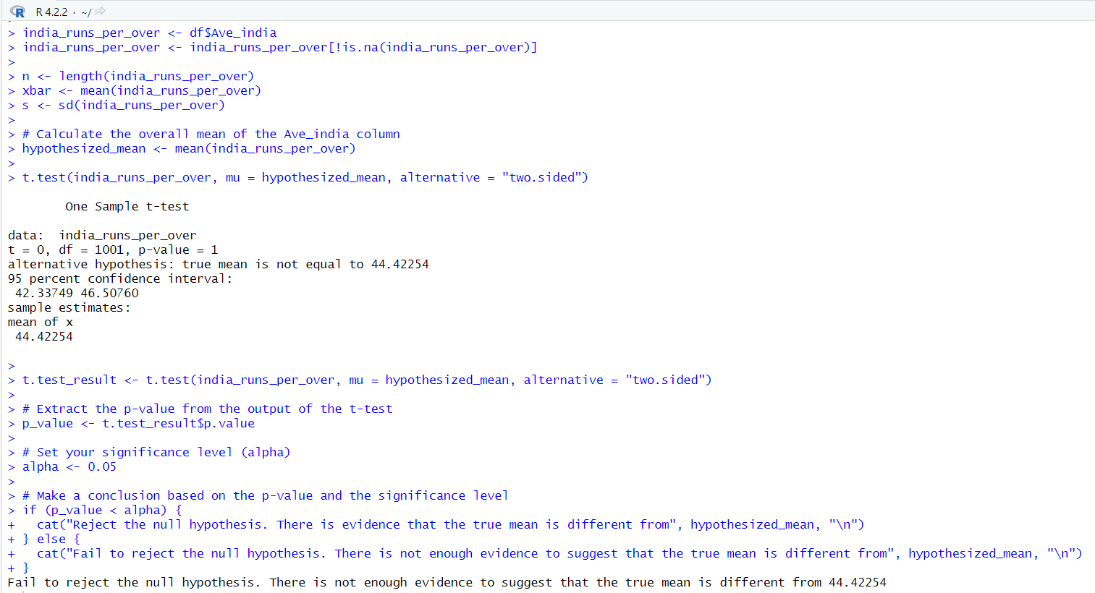

Hypothesis 2:

In the second hypothesis we are going to perform two sample t test and conclude our hypothesis result.

Null Hypothesis: There is no significant difference between the average score of India in ODI matches when compared to the average score of opposing teams.

Alternative Hypothesis: There is a significant difference between the average score of India in ODI matches when compared to the average score of opposing teams.

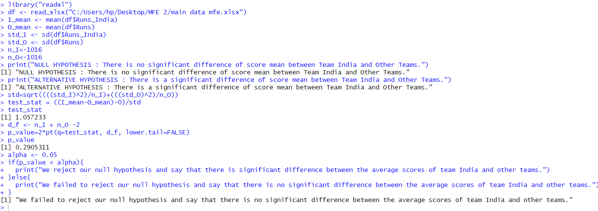

Hypothesis 3:

In the third hypothesis we are going to perform Chi Squared test and conclude our hypothesis result.

Null Hypothesis: There is no significant difference between the scores of the Indian Cricket team from the overall scores of the other ranges while checking specific ranges.

Alternative Hypothesis: There is a significant difference between the scores of the Indian Cricket team from the overall scores of the other ranges while checking specific ranges.

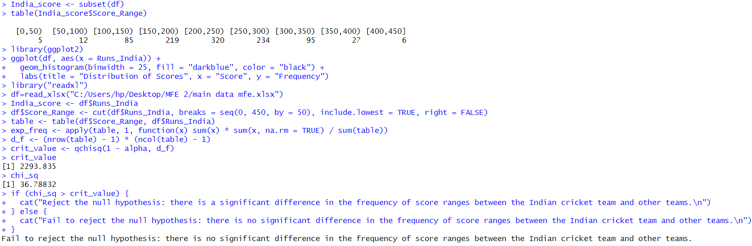

**ANALYSIS AND RESULTS:**

Output of the hypothesis performed :-

* Hypothesis testing of hypothesis first tell us that there is no significant difference between average score of India per over from a specific value (Hypothesised value).
* Hypothesis testing of hypothesis second tell us that there is no significant difference between average score of India in ODI matches from average score of opposition teams played with India.
* Hypothesis testing of hypothesis third tell us that there is no significant difference of Indian score from specific ranges of overall score of other teams.

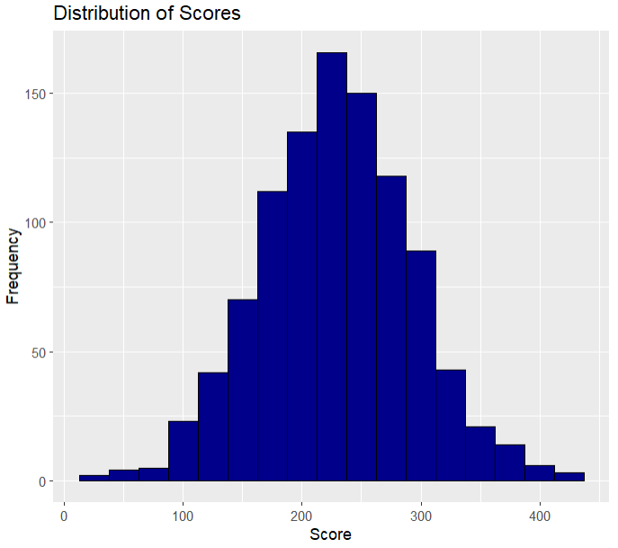

**ADDITIONAL PRESPECTIVES ON THIS MIGHT INCLUDE**

* Analysis of individual player performances - In addition to comparing team performances, individual player performance analysis can offer insightful information about a player's abilities, weaknesses, and contributions to the performance of the team as a whole.
* Comparison of performance across competitions - Analysing the consistency and adaptability of the Indian cricket team and other international teams can be done by comparing their performance across competitions.
* Utilisation of more sophisticated statistical techniques - Although chi-squared, one-sample t-tests, and two-sample t-tests are helpful statistical tests, more sophisticated statistical techniques, such as regression analysis and machine learning, can offer more in-depth insights into cricket performance.
* Comparison of performance under various conditions - Examining how the Indian cricket team and other international teams perform under various circumstances, such as various playing surfaces, weather conditions, and game formats, can give important insights into their adaptability and versatility.
* Integration of qualitative analysis - Along with quantitative analysis, integrating qualitative analysis, like player and coach interviews, can offer insightful context for the elements that affect cricket performance.

**CONCLUSION:**

The methodology described, in summary, entails gathering information from the Indian cricket team's websites for World Cup ODI matches and comparing it to information from other international teams using various tests, such as the chi-squared, one-sample t test and two-sample t test.

A statistical hypothesis test known as the chi-squared test is employed to determine whether there is a significant difference between the observed and expected data. While the two-sample test is used to compare two sets of observed data to see if there is a significant difference between them, the one-sample test is used to compare observed data with expected data based on a known probability distribution.

When comparing sample means and independent groups in research studies, the one-sample t-test and the two-sample t-test are both crucial statistical tools. When comparing the means of two distinct groups, the two-sample t-test is used, while the one-sample t-test is used to compare a sample mean to a known population mean. Both tests are useful in determining whether there is a significant difference between two means and can shed light on how well a product or treatment works. In the end, using these tests aids researchers in deriving meaningful conclusions from their data and making defensible decisions based on the outcomes.

In general, using this methodology will help you analyse your data and come to wise conclusions. The chi-squared test and two-sample tests are two examples of statistical tests that researchers can use to find significant differences between data sets and make inferences about their research.

**REFERENCES**

* <https://stats.espncricinfo.com/ci/engine/stats/index.html?class=2;filter=advanced;orderby=team_score;size=200;spanmin1=1+jan+1970;spanval1=span;team=6;template=results;type=team;view=match>
* <https://stats.espncricinfo.com/ci/engine/team/6.html?class=2;filter=advanced;orderby=amount_balls;size=200;spanmin1=1+jan+1970;spanval1=span;template=results;type=team;view=innings;wrappertype=print>
* <https://www.kaggle.com/datasets/kiranchowdary/india-odi-history?select=file_cricket.csv>